

**CYPRUS INTERNATIONAL UNIVERSITY**

**Vocational School**

**Computer Technologies & Programming Department**

**GRADUATION PROJECT**

**E-COMMERCE WEBSITE**

|  |  |
| --- | --- |
| **Ombili Santos** | **20164910** |
| **Name2** | **2016xxxx** |
| **Name3** | **2016xxxx** |
| **Name4** | **2016xxxx** |

**North Cyprus, 2018**



**CYPRUS INTERNATIONAL UNIVERSITY**

**Vocational School**

**Computer Technologies & Programming Department**

**GRADUATION PROJECT**

**ECOMMERCE WEBSITE**

|  |  |
| --- | --- |
| **Ombili Santos** | **20164910** |
| **Name2** | **2016xxxx** |
| **Name3** | **2016xxxx** |
| **Name4** | **2016xxxx** |

Supervisor

**Asst.Prof.Dr. Jasmine BAY**

**North Cyprus, 2018**



**ACKNOWLEDGMENT**

We would like to express our gratitude towards our graduation project lecture Asst. Prof. Dr. Jasmine BAY for the support she has given for our diploma in Computer Programming. Her guidance assisted us on paving ways to tackle the issues we have faced when it came to decision making. We would also like to thank the University’s IT department for ensuring that the communication network specifically the internet connection on campus remained operational at all times. Last but not least, we would like to thank our lectures who have been lecturing us for the past years by filling up our minds with various technological and practical knowledge on how to get the job done. All those long hours of self-assignments and nerve breaking quizzes and exams has helped us achieve our ultimate goal to complete our graduation project.

Thank you.



**ABSTRACTION**

It’s no secret that E-commerce has dominated the commerce industry by allowing consumers to purchase their products via online. Online websites makes it convenient enough not only to consumers but business owners by providing live analytic data on which areas of the business needs improvements. One of the biggest benefits of a business owning an online website is the opportunity to broaden their business brands by bringing and reaching a larger volume of customers. This document contains the information on how a team of four students designed and developed an e-commerce shopping website that contains management tools that influence good decision making.



**TABLE OF CONTENTS**

Contents

ABBREVIATIONS AND ABBREVIATIONS 6

TABLE LIST 7

FIGURE LIST 8

The management panel 9

A. Side Panel 9

B. Main display 9

1. Home Button menu item: 10

2. Orders menu item: 10

This menu item displays the following analectic information: 10

3. Products 11

4. Customers 11

5. Reports 12

6. Suppliers 12

7. Admin section 13

CONCLUSION 15

References 16



# ABBREVIATIONS AND ABBREVIATIONS

|  |  |
| --- | --- |
| **e-commerce** | Electronic commerce |
| **B2B** | Business-to-Business |
| **B2C** | Business-to- Consumer |
|  |  |
|  |  |
|  |  |
|  |  |
|  |  |
|  |  |
|  |  |
|  |  |
|  |  |
|  |  |
|  |  |
|  |  |
|  |  |
|  |  |



# TABLE LIST



# FIGURE LIST

Figure 1 Homepage of Management Control panel 9

Figure 2 Homepage of Management Control panel 10

Figure 3 Homepage of Management Control panel 11

Figure 4 Homepage of Management Control panel 11

Figure 5 Homepage of Management Control panel 12

Figure 6 Homepage of Management Control panel 12

Figure 7 Homepage of Management Control panel 13

Figure 8 Homepage of Management Control panel 13

# The management panel

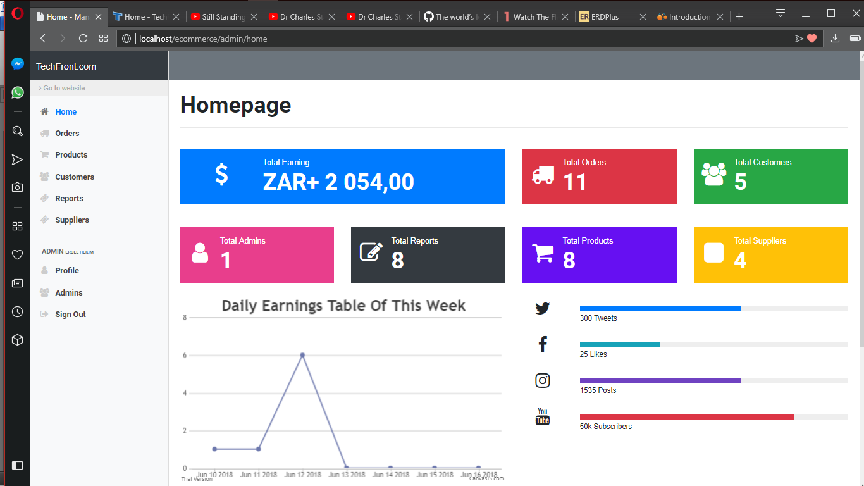

*Figure 1 Homepage of Management Control panel*

One of the most important components of the website is the management panel. This component is the administration portion of the website. Apart from being used as a website management tool, it is also used to assist the business management making use of the website with strategic decision making.

The appearance of the management panel is regarded as the most important aspects. If major details are buried deep in the panel, a manager would not want to look for the required data as it is time consuming.

**There are two components that will hold and display the basic control panels**

## A. Side Panel

Holds the menu list items of the management panel that holds information about the activities done via the website such as; the total amount of sales.

## B. Main display

Displays the results contained in the menu list from the side panel.

**These are the basic menu list items that the side bar panel displays:**

* **Home**
* **Orders**
* **Products**
* **Customers**
* **Reports**
* **Suppliers**
* **Admin**
* **Profile**
* **Admins**
* **Sign Out**

## 1. Home Button menu item:

This menu item is automatically selected for view in the main display window when the user logs in.

The Home button displays the most important statistical information needed by managers of the business. It is convenient enough for the managers not to search for the relevant information needed to make quick decision making as all these analectic information is found in the Home item.

## 2. Orders menu item:

The orders menu item contains information about the products that have been ordered by the online customers.

## This menu item displays the following analectic information:

* Top buyers in terms of gender
* The successful orders that have been paid for by the customer for the day and month
* The list of successful orders with additional information such as customer name

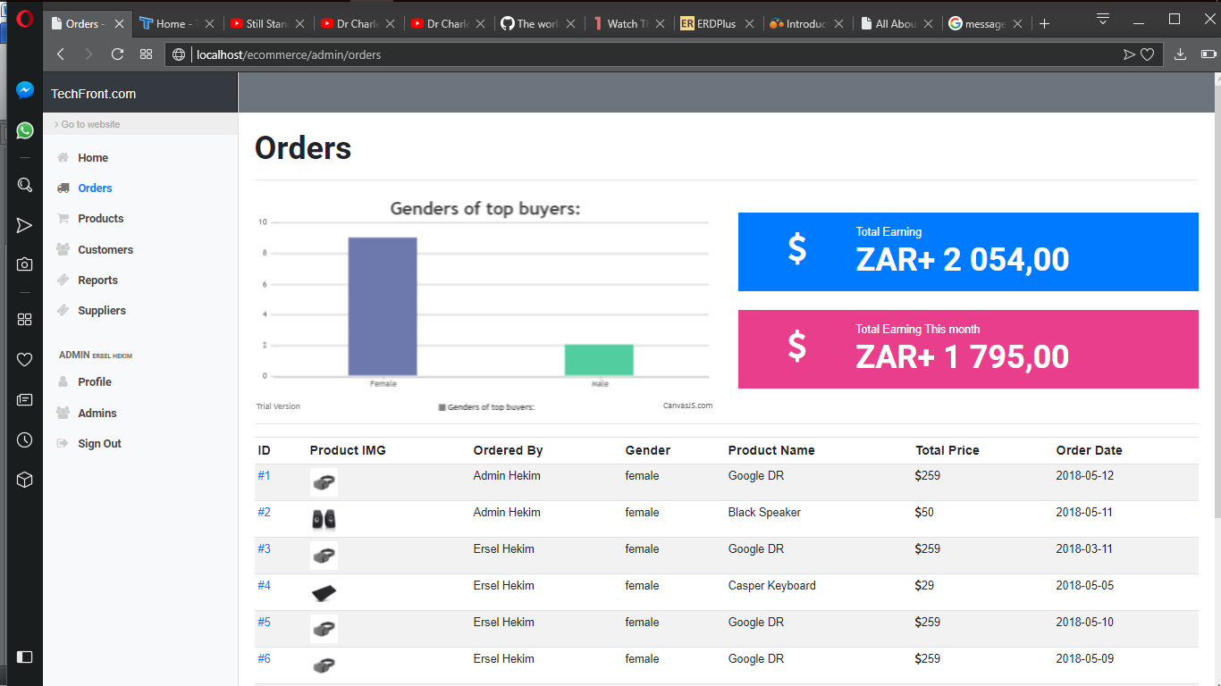

*Figure 2 Information content from the orders*

## 3. Products

The products menu item displays the list of products sold by the business and also a graph that shows the best-selling products by category.

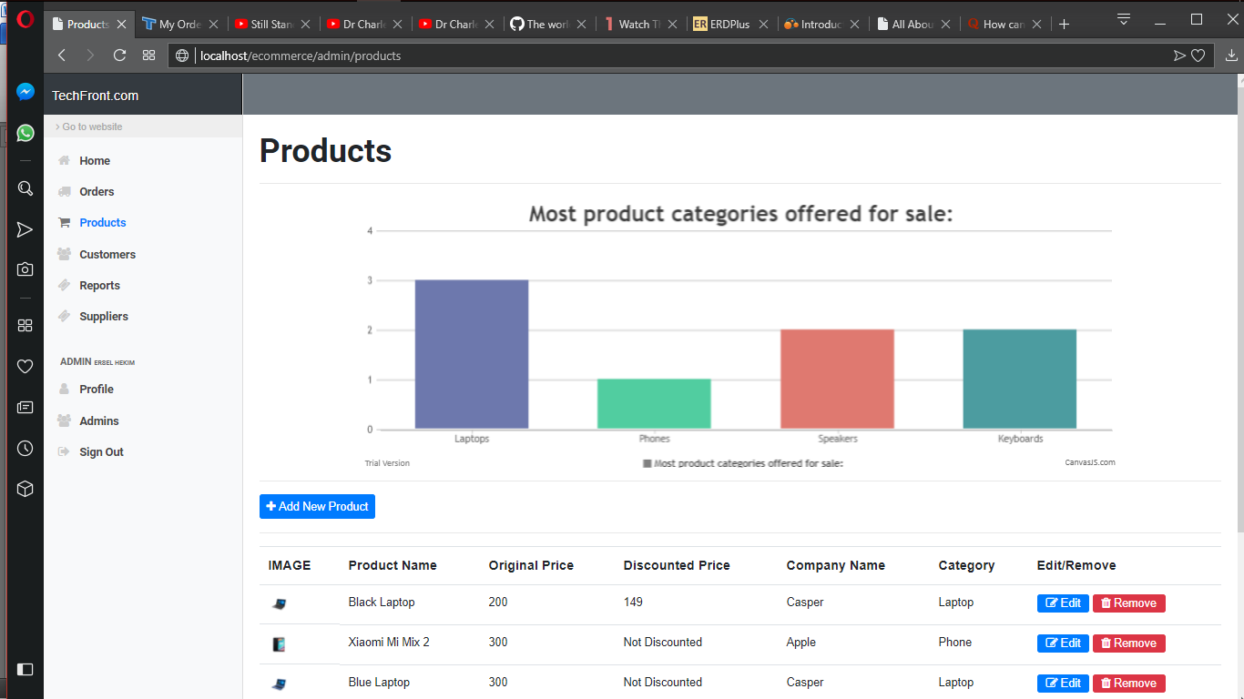

*Figure 3 Homepage of Management Control panel*

## 4. Customers

The customer’s page contains the list of all registered customers on the website such as the profile image of the customer and most importantly the registration date.

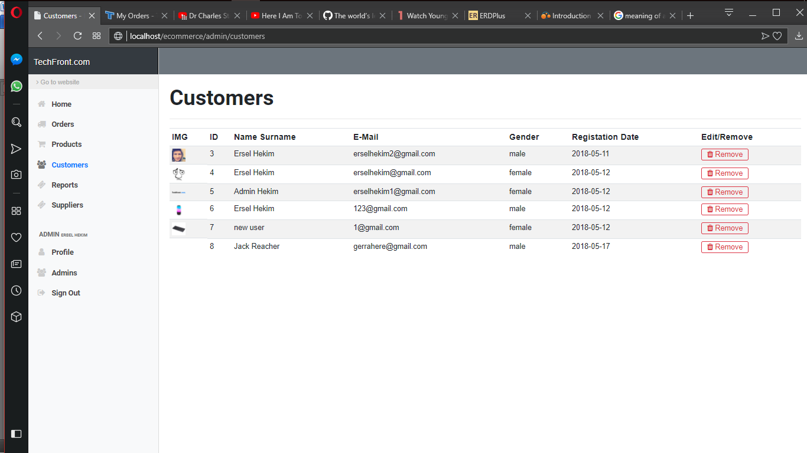

*Figure 4 Homepage of Management Control panel*

## 5. Reports

The most important component of the management panel is the Reports section. For adequate reporting to top business management and effective decision making, the report section provides the analytic data that can be used to improve the web service of the business. By analysing the categories that have the most customer complaints, managers would have to look into it to improve the customer services. Managers would prefer less customer complaints over non buying customers.

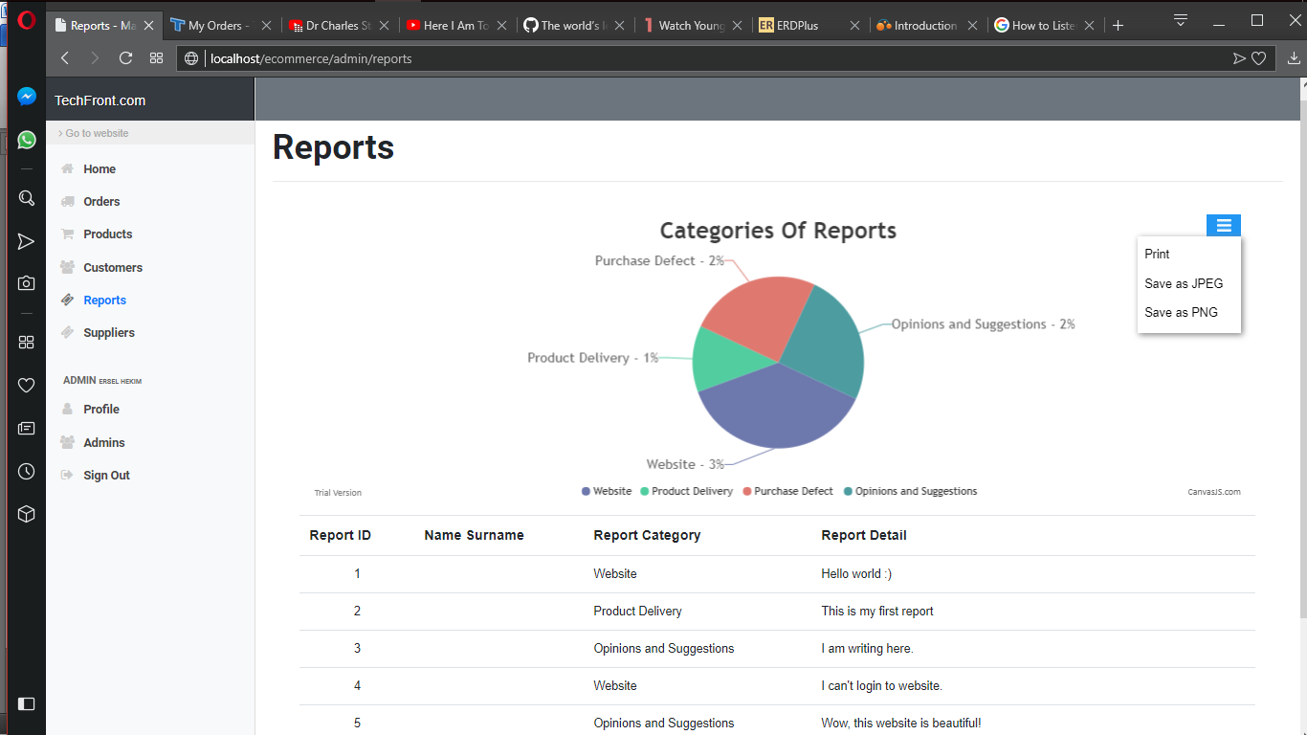

*Figure 5 Homepage of Management Control panel*

## 6. Suppliers

Since this type of e-commerce business uses a B2C (Business to Consumer) transaction, the business itself also makes use of a B2B (Business-to-Business) transaction in order to have these products to sell to consumers. Being able to have a suppliers section on the management panel, makes it easier for the managers to decide which suppliers should be removed and which should be added based on sale returns.

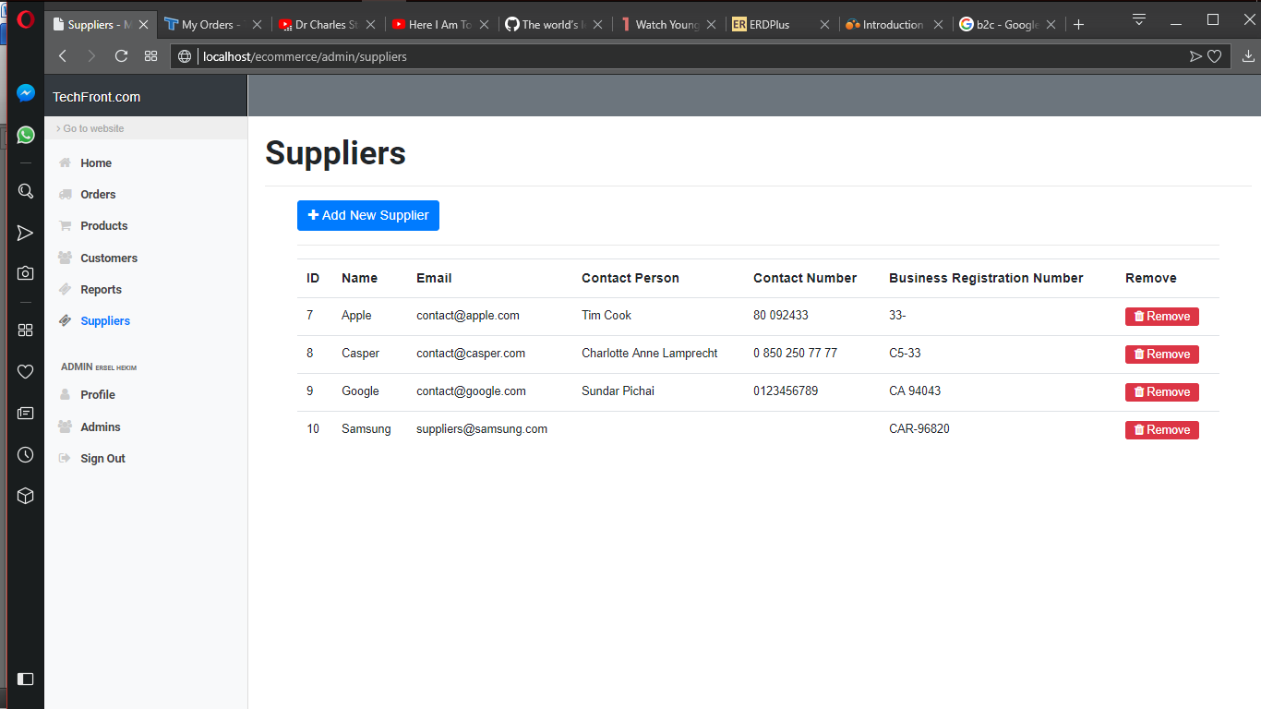

*Figure 6 Homepage of Management Control panel*

## 7. Admin section

The admin section contains information about the currently logged on administrator and other registered administrator. From the Profile subpage, it displays the profile details of the current logged in administrator. The Admins page displays the list of other system admins registered to the website. Other administrators are able to delete other administrators should it be deem necessary

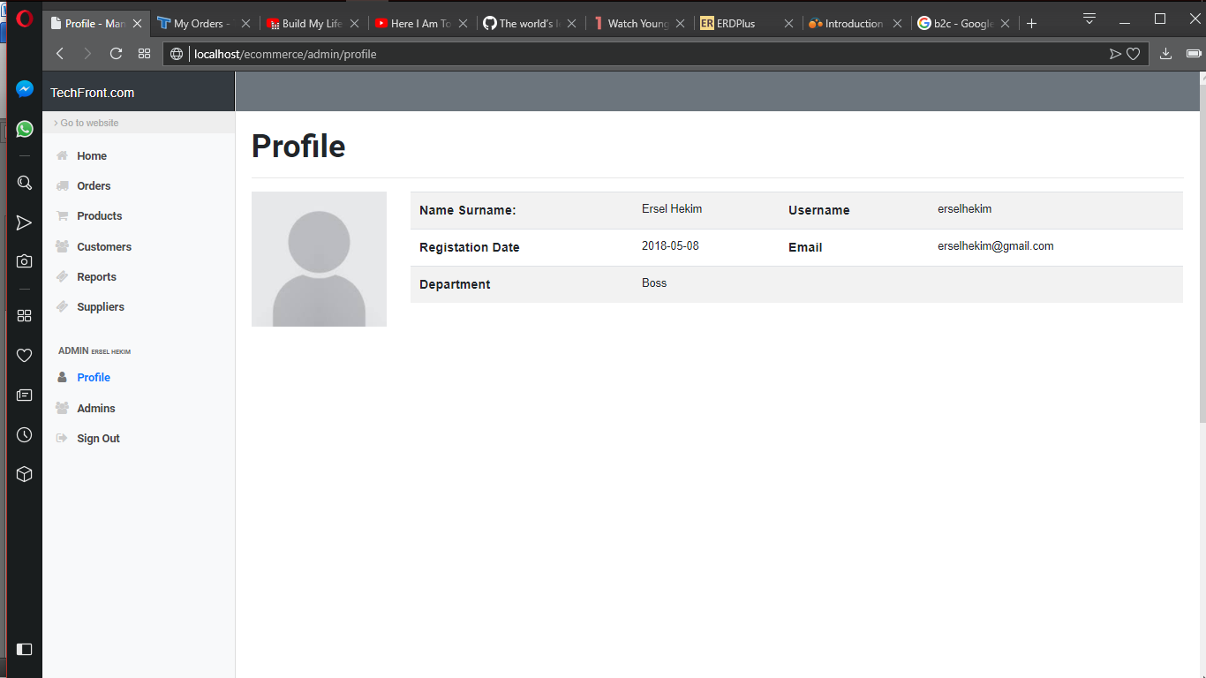

*Figure 7 Homepage of Management Control panel*

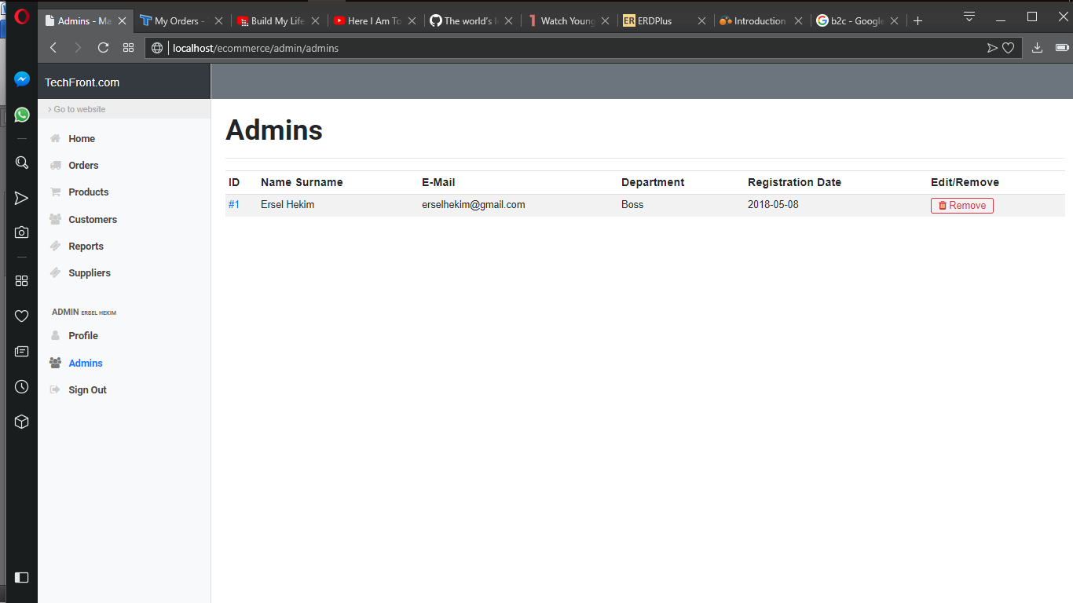

*Figure 8 Homepage of Management Control panel*



# CONCLUSION



# References

//if your source was a website

[1] “Types of VPN and types of VPN Protocol,” May. 24, 2016. [Online]. Available: https://www.vpnoneclick.com/types-of-vpn-and-types-of-vpn-protocols/.

[Accessed: May. 1, 2018].

*//if your source was a book or thesis paperot video*

[2] “Word 2016 Tutorial Inserting a Table of Figures Microsoft Training” March.17, 2003. [Online Video: Todd Lammle]. Available: https://youtu.be/zDMBzTDQfJ0

[Seen on: May. 18, 2018]